**FANOFAN**

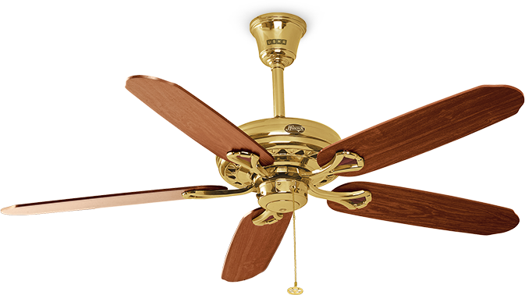

User Guide

Student Details

|  |  |
| --- | --- |
| Student Name | Student.ID |
| Shazmina | Student1365583 |
| Arooba | Student1362791 |

Faculty Details

Sir Omair Mushtaq

Coordinator

Miss Wajeeha

Curriculum

7062

Home Page

1. Logo

2. Navbar

3. Image Slider

4. Upcoming Products

5. Products images

6. Footer

From home you can navigate to any page. It contains short brief to the shop and a section for categories. Popular products and popular categories are available on home page. Footer is available with privacy and return policy

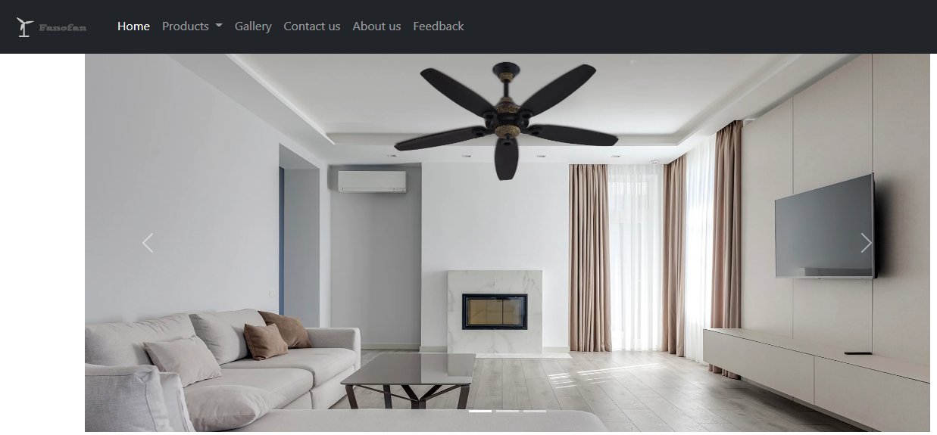

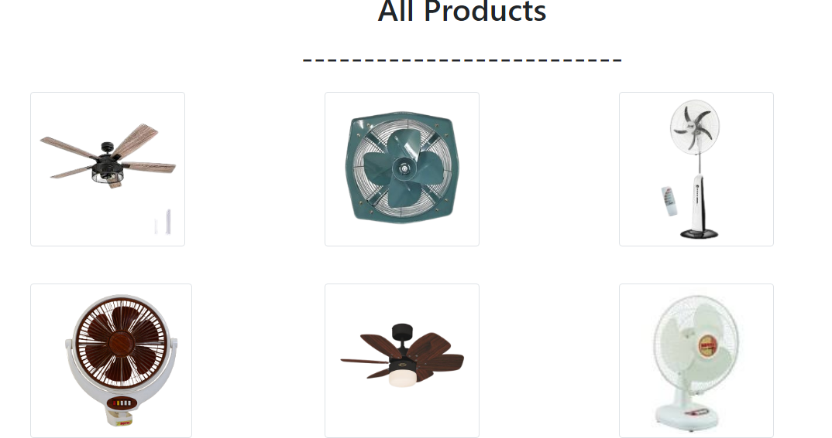

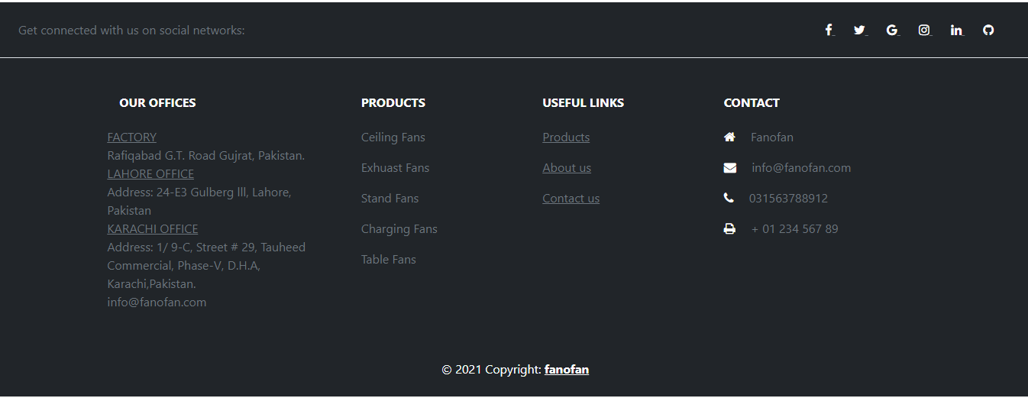

**ABOUT US**

About Us Page Contain.

1. Logo

2. Navbar

3. Mission

4. Vision

5. Info

6. Footer

About Us Page Contains the brief detail of shop and company ,it has all the necessary information.





**CONTACT US**

Contact us page contain.

1. Logo

2. Navbar

3. Map

4. Contact us

5. Footer

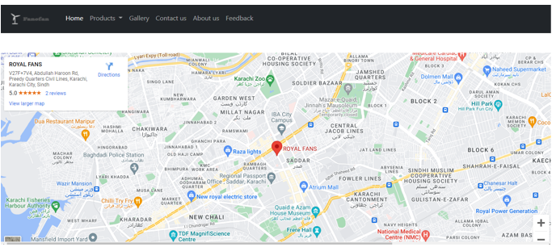

**Contact Form**

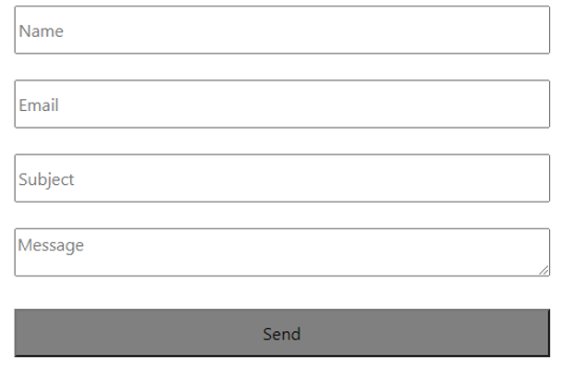



**FEEDBACK PAGE**

Feedback page contain.

1. Logo

2. Navbar

3. Product review image

4. Feedback us

5. Footer.



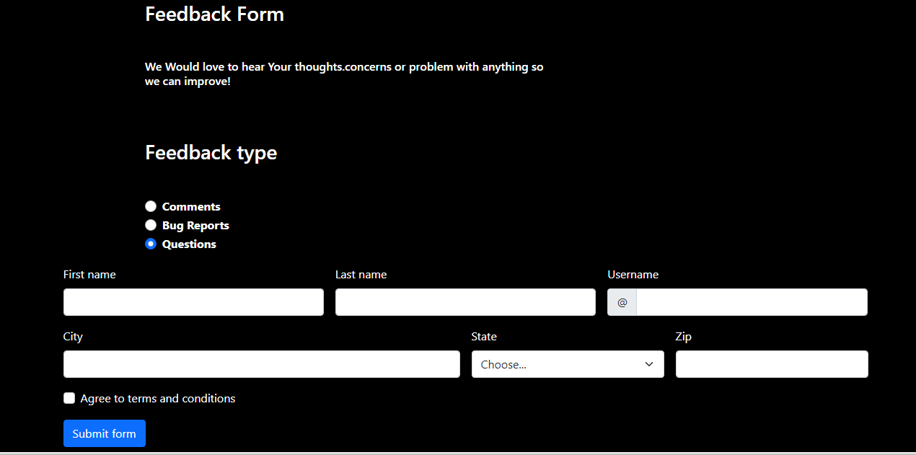



**GALLERY**

Gallery page contain.

1. Logo

2. Navbar

3. Product image

4. Footer

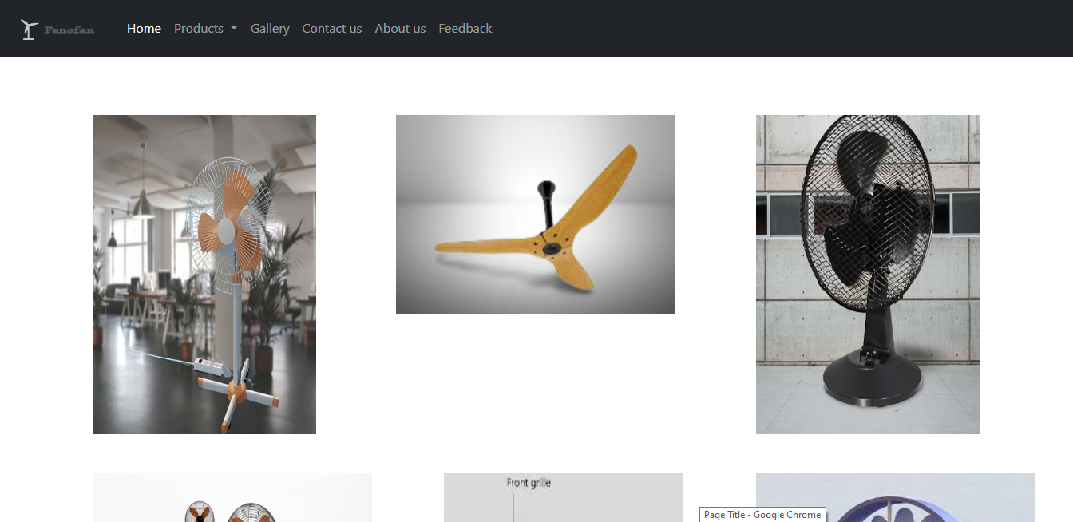

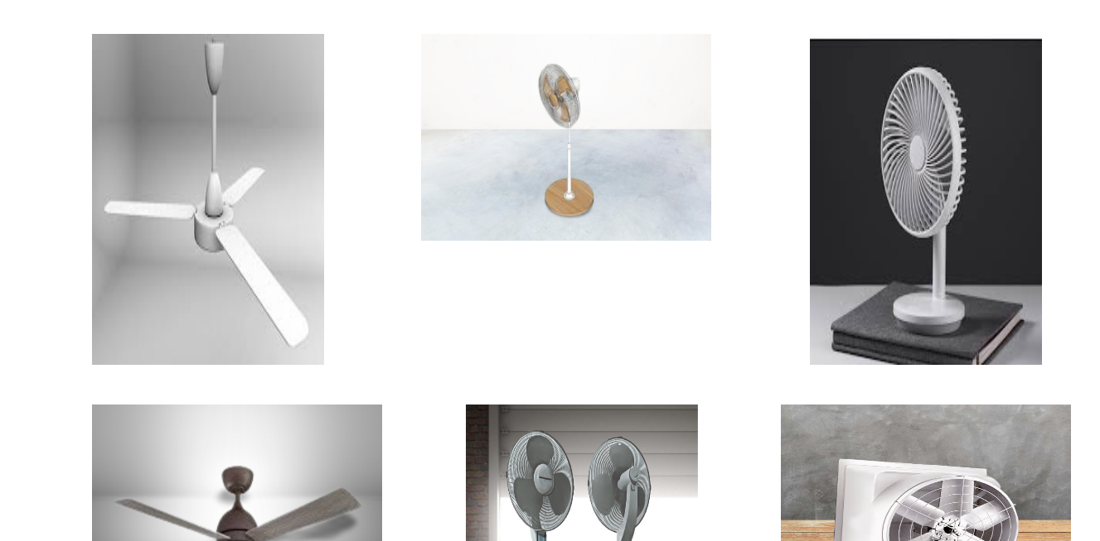

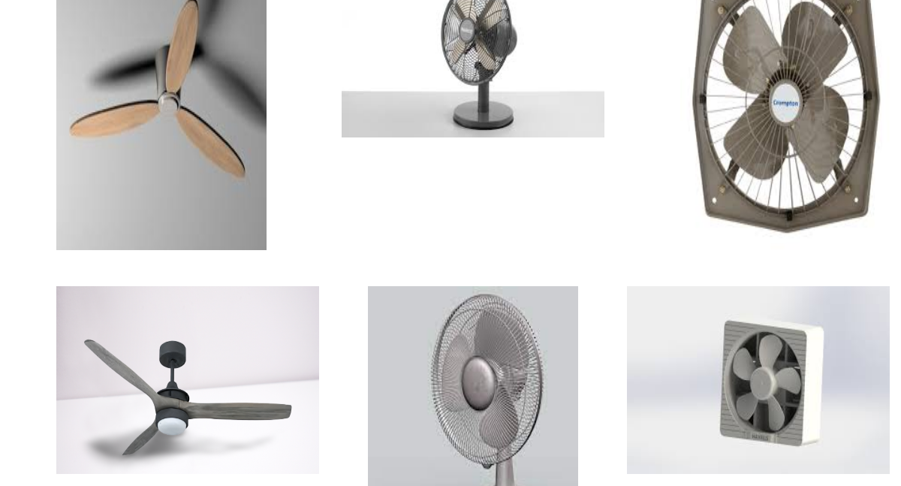

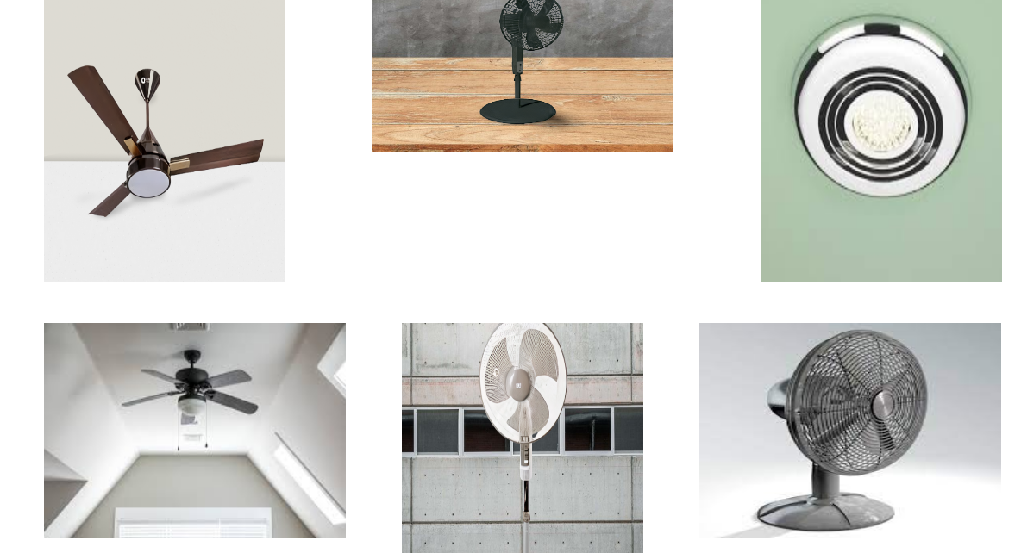

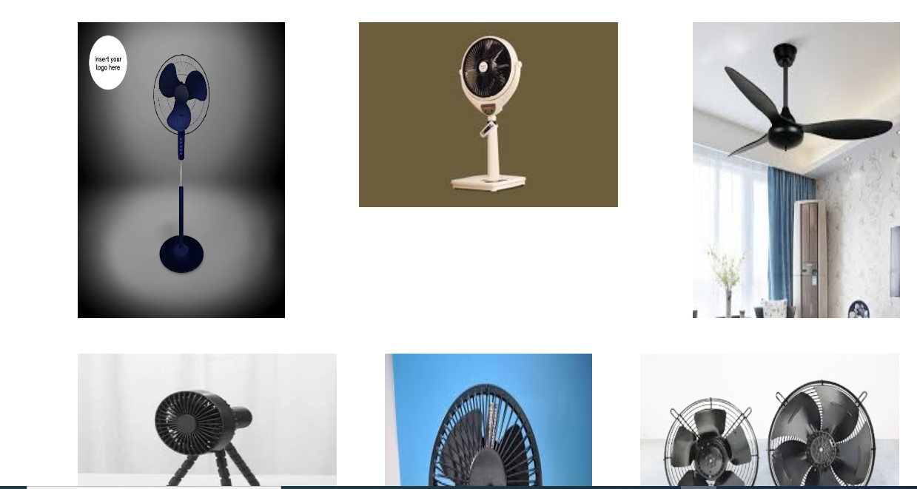



**PRODUCT**

Product page contain.

1. Logo

2. Navbar

3. Product card

4. product deatails

5. Footer.

